**ASSIGNMENT 2 FRONT SHEET**

|  |  |  |  |
| --- | --- | --- | --- |
| **Qualification** | **BTEC Level 5 HND Diploma in Computing** | | |
| **Unit number and title** | Unit 2: Networking Infrastructure | | |
| **Submission date** | 18/12/2021 | **Date Received 1st submission** | 18/12/2021 |
| **Re-submission Date** | 04/01/2021 | **Date Received 2nd submission** | 04/01/2021 |
| **Student Name** | Bùi Hương Linh | **Student ID** | GBH200662 |
| **Class** | GCH1002 | **Assessor name** | Michael Omar |
| **Student declaration**  I certify that the assignment submission is entirely my own work and I fully understand the consequences of plagiarism. I understand that making a false declaration is a form of malpractice. | | | |
|  |  | **Student’s signature** |  |

**Grading grid**

|  |  |  |  |  |  |  |  |
| --- | --- | --- | --- | --- | --- | --- | --- |
| P5 | P6 | P7 | P8 | M3 | M4 | D2 | D3 |
|  |  |  |  |  |  |  |  |

|  |  |  |
| --- | --- | --- |
| **❒Summative Feedback: ❒Resubmission Feedback:** | | |
| **Grade:** | **Assessor Signature:** | **Date:** |
| **Lecturer Signature:** | | |

# Introduction

A school requested that a LAN for more than 100 users be designed and distributed across three rooms.

* Request:
* During peak hours, it can accommodate more than 100 individuals.
* Students have no administrative rights.
* Approximately 200 students, 20 teachers, and 5 administrators including a program and learning manager, as well as three computer network administrators •Resources include 50 student computers, 28 staff PCs, and 2 printers.
* One room of teacher, administrators and network adminstrators.
* Two room for students and teachers.

# Task 1: Provide a logical/physical design of the networked system with a clear explanation and addressing table (P5)

1. The difference between logical and physical network design

I.1. What is a Logical Design?

* A logical network is one that appears to the user as a single, distinct entity, despite the fact that it may be either a composite of multiple networks or a subset of a larger network; it is defined by its IP addressing scheme.
* Logical design is concerned with how data connections function within a computer network and how devices interact with one another. In addition, the graphic depicts nodes such as servers, routers, and switching as they would appear in a physical network design. A logical network design focuses on how to design your facility and company. Administrators can create a variety of network logic diagrams, such as maps for WAN, LAN, AWS, Cisco, and other applications. These diagrams are extremely detailed or provide an overview of high standards.

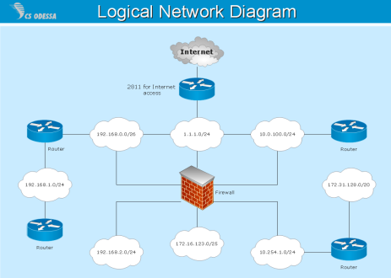

Figure 1: Logical Design

II.1. What is a Physical Design?

* A system's physical design is a graphical representation of the system's internal and external entities, as well as data flows into and out of these entities.
* A system entity (person, place, or object) that changes data is referred to as an internal entity. Internal entities include accounting clerks (people), departments (locations), and computers (things). An external entity, on the other hand, is a non-system entity (person, place, or thing) that modifies data. In reality, the physical design is concerned with the actual input and output operations of the system. This is defined in terms of how data is entered into a system, authenticated, processed, and displayed as output.

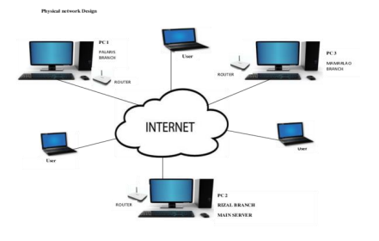

Figure 2: Physical Design

I.3. Compare between logical and physical network design

* The physical design layout defines the components of the logical design network that are present in a given network architecture. Furthermore, it refers to the configuration of computers and other physical components. Fiber, ISDN, and Ethernet are among its components. The logical design network in a network assumes a specific piece of a conceptual design and assigns it a logical role within that framework. Its components are network IP structures such as Class A, B, or C address schemes.

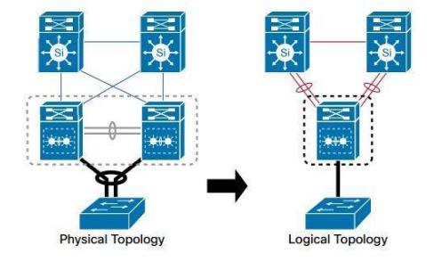

Figure 3: The different between logical and physical design

* Different point:

|  |  |  |
| --- | --- | --- |
|  | Advantages | Disadvantages |
| Logical design | * Remove redundancies Logical network diagrams will clearly show you what is and is not redundant. * Firewalls Logical network diagrams can be used to ensure that your firewall rules are still correct. * Planning for capacity Although physical network charts are important for capacity planning, logical charts can also help. They allow you to map network expansion or change and determine the impact. * Information sharing on the network, If you need to share information on the network but want to conceal physical information on the network, you can use a logical network diagram. * Problem-solving If Service is between two IP addresses, a logical network diagram can be used to quickly rule out a firewall problem. | * A new device cannot be added or removed from the network. * In the ring topology, if any node fails, the entire network fails because the connection is broken. |
| Physical design | * Compliance is important for demonstrating compliance with key regulations such as PCI, which may necessitate specific, secure architecture. * Network Administration and Management Admins can use device inventory to get a visual overview of their environment, see which nodes are up or down, and see how their infrastructure performs under different loads. * Problem-solving When issues arise, administrators require immediate insight into what is causing the bottleneck. | * Requires monitoring software * Expensive equipment |

1. Discuss and explain the user requirements for general network design.

|  |  |  |
| --- | --- | --- |
| Room | Role | Devices |
| 1 | Students and Teachers | 20 PCs for students, 2 PCs for teachers |
| 2 | Students and Teachers | 30 PCs for students, 3 PCs for teachers |
| 3 | Teachers and Admins | 15 PCs for teachers, 5  managers, 3 adminstrators and 2 printers |

* Explan: The whole topology is linked to a router, which assists in the installation of all school network gateways, including lans and subnetmasks.
* Because there are 55 computers split between the first and second rooms, I use a 36 port switch in the second room and a 48 port switch in the first.
* Finally, the third room is designated for administrators and teachers, therefore it is equipped with a variety of technologies such as a computer, laptop, printer, wireless router, and so on. So, in order to connect all of the gadgets, I'll need the switch, which has 48 ports in total.
* A logical design of the network based on the specific requirements of the user.

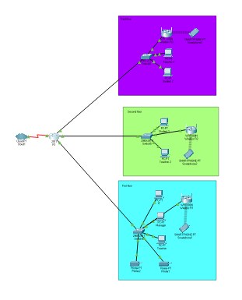

Figure 4: The numbers r IPs are the logical design

* The physical design of this network is based on the specific requirements of the user.

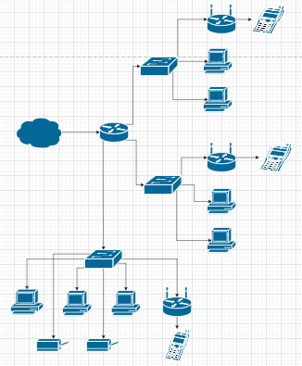

Figure 5: Physical and logical explanation

* The address table of the network devices used in your design above.

|  |  |  |  |  |  |
| --- | --- | --- | --- | --- | --- |
| Device | Interface | IP | Gateway | Subnetmask | DNS |
| Router | Serial0/0/0 | 8.8.8.8 |  | 255.255.255.0 |  |
| Router | GiganitEthernet0/0 | 192.168.19.1 |  | 255.255.255.0 |  |
| 20 student PCs | FastEthernet0 | 192.168.19.11 | 192.168.19.1 | 255.255.255.0 | 8.8.8.8 |
| 30 student PCs | FastEthernet0 | 192.168.19.13 | 192.168.19.1 | 255.255.255.0 | 8.8.8.8 |
| Admin PCs | FastEthernet0 | 192.168.19.2 | 192.168.19.1 | 255.255.255.0 | 8.8.8.8 |
| Teacher PCs | FastEthernet0 | 192.168.19.4 | 192.168.19.1 | 255.255.255.0 | 8.8.8.8 |
| Manager PCs | FastEthernet0 | 192.168.19.3 | 192.168.19.1 | 255.255.255.0 | 8.8.8.8 |
| Printer 1 | FastEthernet0 | 192.168.19.22 | 192.168.19.1 | 255.255.255.0 | 8.8.8.8 |
| Printer 2 | FastEthernet0 | 192.168.19.33 | 192.168.19.1 | 255.255.255.0 | 8.8.8.8 |
| Wireless Devices 1 | FastEthernet0 | DHCP | DHCP | DHCP | DHCP |
| Wireless Devices 2 | FastEthernet0 | DHCP | DHCP | DHCP | DHCP |
| Wireless Devices 3 | FastEthernet0 | DHCP | DHCP | DHCP | DHCP |
| Wireless R1 | FastEthernet0 | DHCP | DHCP | DHCP | DHCP |
| Wireless R2 | FastEthernet0 | DHCP | DHCP | DHCP | DHCP |
| Wireless R3 | FastEthernet0 | DHCP | DHCP | DHCP | DHCP |

Table 1: Addressing table for the network

# Task 2 - Evaluate the design to meet the requirements (P6)

# Steps to create a LAN Network:

* 5 steps:
* Identify the local services:
* One room of teacher, administrators and network admin
* During peak hours, it can accommodate more than 100 individuals
* Two room for students and teachers
* Students have no administrative rights.
* Identify how many devices will have to connect to the network
* Resources include 50 student computers, 18 staff PCs, and 2 printers and using cables to workstations.
* Select and purchase a switch or cable router:

|  |  |  |
| --- | --- | --- |
| **Equipment** | **Amount** | **Price** |
| Router 2911 | 3 | 80.000.000 VND |
| Switch 2960 plus | 4 | 88.000.000 VND |
| Printer | 2 | 8.500.000 VNĐ |
| Cable internet RJ45 | 1500m | 6.800.000 VNĐ |
| Cable CINYOBO CYB-GX-04250 | 250m | 825.000 VNĐ |
| PC Dell Vostro 3670 | 70 | 700.000.000 VND |
| Wireless Linksys EA2750 | 3 | 6.500.000 VNĐ |
| Server Dell Power Egde T30 Tower | 2 | 50.000.000 VND |
| Total |  | 1.500.000.000 VNĐ |

* Design and setup
* Test the services and Internet connectivity

# Justify the choice of devices for your network design.

* **Router 2911**
* I use router 2911 instead of 1841 because it is more modern and full of ports for design
* **Switches 2960 plus** 
  + Allow internal connection configured as a firewall
  + Connected via straight copper cable
* **Generic PC and printer**
* End device for user connecting into the network

1. Produce a test plan to evaluate this design for the requirements of bandwidthand cost constraints as per user specifications.

|  |  |  |  |
| --- | --- | --- | --- |
|  | Activity | Expected | Reason |
| 1 | Ping Teacher3 to Student 2 | Successful | Same network |
| 2 | Ping Manager PCs to IT | Successful | Same network |
| 3 | Ping Manager PCs to Printer 1 | Successful | Same network |
| 4 | Ping Teachers 2 to  Wireless R2 | Failed | Different wifi router |
| 5 | Ping Teacher PCs to Printer 1 | Successful | Same network |
| 6 | Ping Wireless  R1 to R2 | Successful | Same networks |
| 7 | Ping Manager PCs to Printer 2 | Successful | Same networks |
| 8 | Ping Teacher to Printer 2 | Successful | Same networks |

# Task 3 - Implement a networked system based on a prepared design (P7)

1. **Implement**

* Initially, network deployments necessitate the creation of a network blueprint. To simulate, I use Cisco Parket Tracer software, so I should design the network using the IP address table provided. The devices are then linked together as shown in the diagram below



Figure 6: Implement networking system

1. **Configure devices**

* Switch 4:
* En
* Conf t
* Hostname switch4
* Line console
* Login
* Enable secret adminSW4
* Switch 5:
* En
* Conf t
* Hostname switch
* Line console 0
* Login
* Enable secret adminSW5
* Switch 6:
* En
* Conf t
* Hostname switch6
* Line console
* Login
* Enable secret adminSW6
* Router:
* En
* Conf t
* Hostname R1
* Line console
* Login
* Enable secret

## A screenshot of this realization as proof of the network implementation designed above

* Ping Teacher3 to Student2

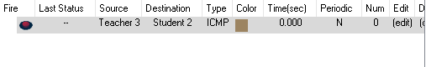

* Ping Manager PCs to IT

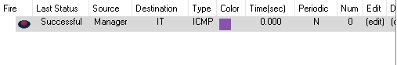

* Ping Manager PCs to Printer1

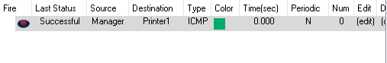

* Ping Teachers 2 to Wireless R2

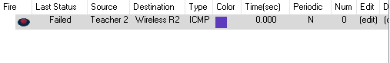

* Ping Teacher PCs to Printer 1

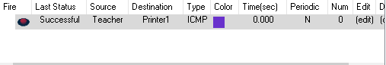

* Ping Wireless R1 to R2

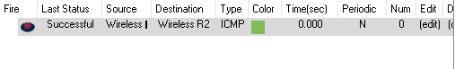

* Ping Manager PCs to Printer 2

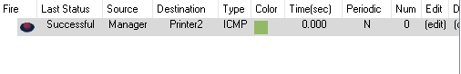

* Ping Teacher to Printer 2

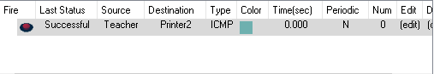

* Evaluate the design:
* Strength: The devices are easily connected to one another, easy to exchange, and monitor data conversion in parallel.
* Weakness: Because devices easily connect to one another, it will be a major issue if someone attempts to attack the network.

# Task 4: Document and analyze test results against expected results (P8)

## Implementation Process.

* System design part including
* 3 Wireless router: It allows everyone to access the internet and connect other devices.
* Smart devices: These are devices that administrators, teachers, and students can personalize.
* 2 printers: used by managers and teachers
* 1 cloud: used by IT and located in room 3
* 70 computers, 25 for room 1, 25 for room 2, and 20 for the administration room.
* 3 Switches 2960-Plus: three on the first floor and two on each of the second and third floors.
* Router 2911: Router 2911 is more advanced than Router 1841 and has a more modern port than Router 1841.
* Connect and configure system
* Printer: I assign a unique IP address to each VLAN's printer. Every type of user has a printer.
* Wireless router: Using DHCP ip
* Smart devices: Using DHCP IP configuration
* Computer: assigning an IP address to each machine; each machine will have its own IP address. A machine is dedicated to only one type of user or one or more VLANs. Computers can communicate with one another in the same room.
* Switch 2960 plus: I configure the switch's ports and assign them to the appropriate VLANs. Then, using trunk mode, I connect the VLANs to each other and to the router.
* Router 2911: I connect the appropriate ports to the floor switches. Configure the VLAN IP addresses at each tier as well. Finally, I use the no shutdown command to turn on the Router.

1. Test rusult

* DHCP

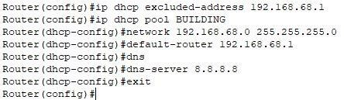

* Router

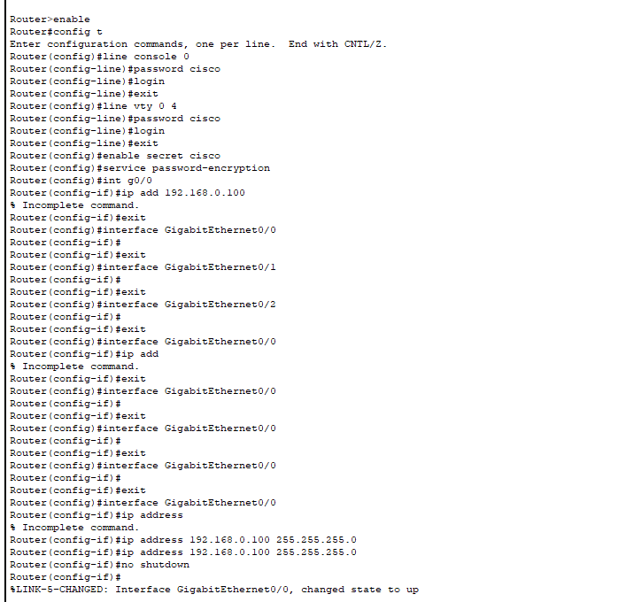

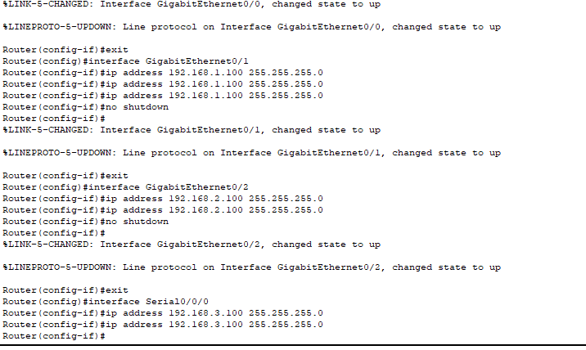

* Configure and set IP for the Wireless routers

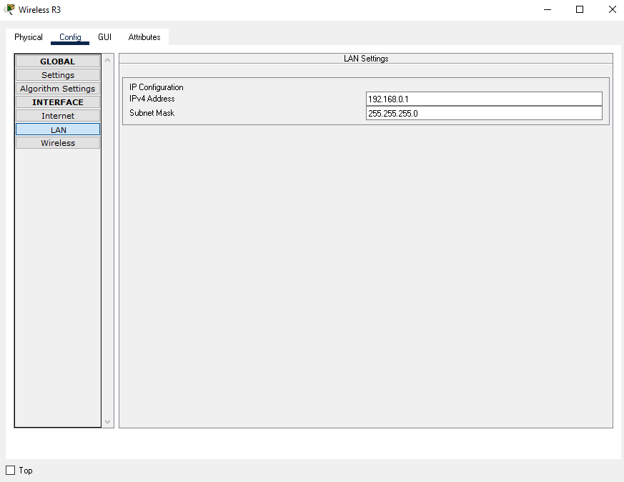

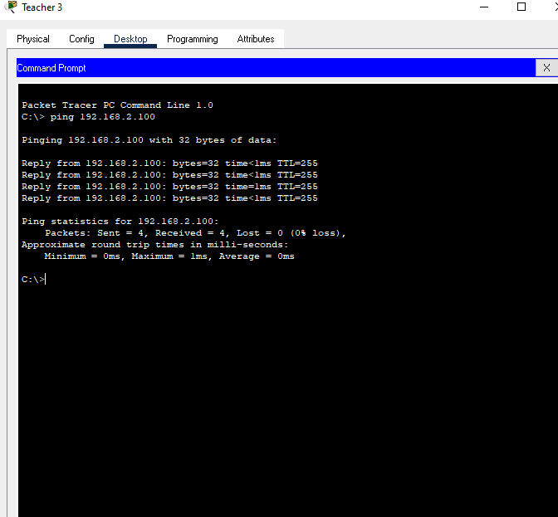

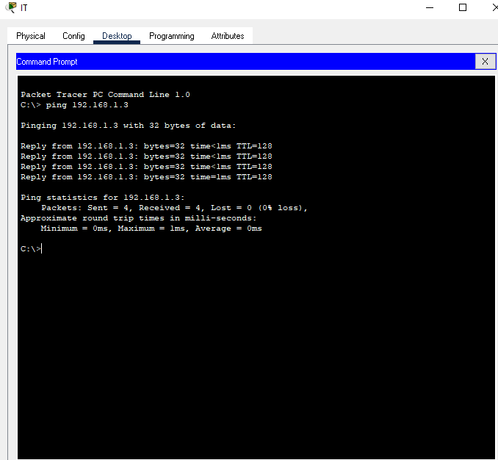

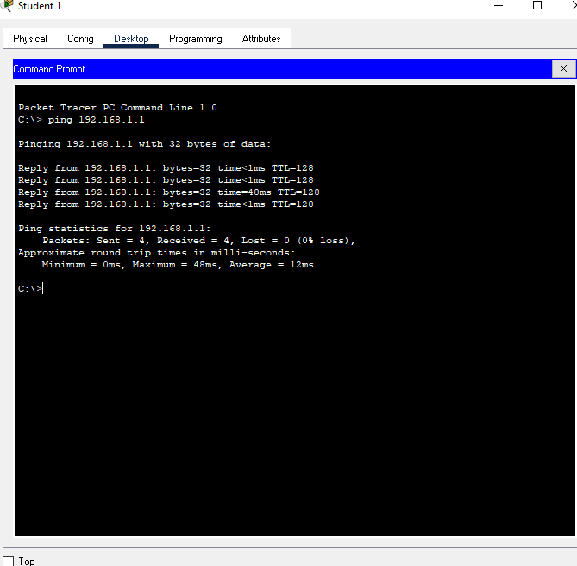

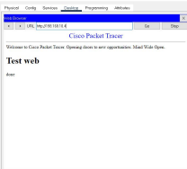

# Conclution

This exercise taught me a lot about network infrastructure and provided me with a wide understanding of the network. I've learnt about the advantages and disadvantages of many types of networks; network, communication, and bandwidth structures; the principles of the network and server types. I created a design networked system. So, based on what I've learnt in this course, I'm going to work on myself and attempt to become a good network engineer.

# References

**There are no sources in the current document.**